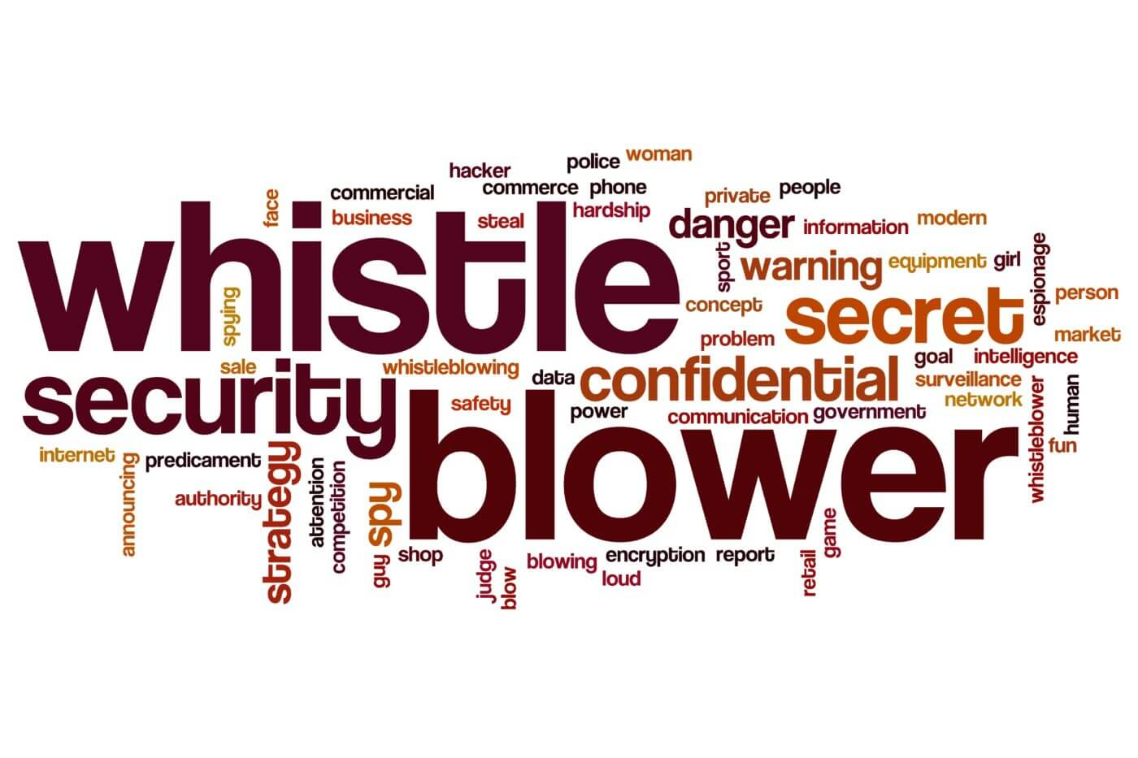

Contents

*1.* *Context* 3

2. What is whistle-blowing? 4

*3.* What should not be reported under this Whistle-blowing policy? 5

*4.* Aims & Scope of Whistle-blowing Policy 5

*5.* Responsibility for the Whistle-blowing Policy 5

*6.* Procedure of Reporting 6

7. Confidentiality 7

8. Protection and Support for Whistle-blowers. 8

9. Handling of reported cases 8

10. False Allegations 9

11. Prevention Report 9

13. Anonymous Reporting. 9

14. Right of Appeal 10

15. Notification 10

# *Context*

Koshish Charitable Trust, founded by young and devoted social activists was registered as a charitable trust Registration no. 4749/IV-338 on 4th August 1997. It is registered under FCRA vide registration no. 031170250 and its FCRA license is valid till 31st of December, 2027.Koshish is basically Human Rights and Child Rights organization.

The Koshish Whistle-blowing system aims to reinforce the organization’s commitment to conducting its business with honesty and integrity and to comply with its policies, values, attitudes and behaviours.

The system provides a channel for reporting of suspected wrongdoing as quickly as possible, in the knowledge that concerns will be taken seriously and investigated appropriately and, in a way, which ensures that those who raise genuine concerns can do so without fear of reprisals. The purpose of this policy is to provide an effective procedure for people to raise their concerns when they believe that abuse, serious malpractice or professional misconduct has taken place.

# What is whistle-blowing?

Literally, "whistle-blowing" means that a party, in good faith, expresses or transmits a concern, allegation or information indicating that a prohibited practice in a KCT or a KCT-financed operation is happening or has happened. The purpose of blowing the whistle is to alert a third party that a person or entity has done or is doing something wrong.

By reporting misconduct in KCT, one alerts the organization to the fact that its stakeholders are being unfairly put at risk or harmed.

This policy applies to all stakeholders including the Secretariat Staff, Principal Recipients, Members and Board Members, projects and programmes funded by donor partners as well as those implemented to report misconduct in connection with any activity of the KCT.

Serious misconduct includes wrongdoing, corruption, bribery or theft. This may include, but is not limited to:

* 1. Financial and procedural malpractices including those relating to mismanagement; misappropriation of funds; Actual or suspected fraud or abuse of authority.
  2. Falsification of organizational records for personal gain or benefit to others on the part of the employees, partners and members of the governing body.
  3. This procedure does not replace other policies and procedures such as the KCT Code of Conduct, the complaints procedure, the Grievance and Harassment and Bullying Policies, Anti-Fraud and Corruption, SHEA and Safeguarding policies and other policies with specifically laid down statutory reporting procedures but will complement such Procedures.
  4. The Whistle-blowing Procedure sets out the framework for dealing with allegations of illegal and improper conduct.
  5. Attempting to conceal any of the above
  6. Criminal activity; Failure to comply with any legal or professional obligation or regulatory requirements; Miscarriages of justice; Improper conduct or unethical behavior; Danger to health and safety; Damage to the environment; Bribery under the Organization’s Anti-Fraud and Corruption Policy; Financial fraud or mismanagement; Participation in or facilitation of criminal tax evasion; Breach of the Organization’s policies and procedures; Conduct likely to damage the Organization’s reputation or financial wellbeing (or that of its subsidiaries); Unauthorized disclosure of confidential information; Negligence; Harassment, bullying; Sexual harassment; Sexual exploitation and abuse; Child or adult at risk abuse; Modern slavery or trafficking; Discrimination (e.g. against someone on the basis of their race or gender); Manager/employee relations; Abuse or excessive use of power; Abuse of trust; Fraudulent procurement; Undeclared conflict of interest; The deliberate concealment of any of the above wrongful acts.
  7. A Whistle-blower is any person who raises a bona fide or genuine concern relating to any of the above wrongful acts, including wrongful acts which may or may not be explicitly covered in the policy, but which may nevertheless be considered a violation of code of conduct.
  8. Should a Whistle-blower acting in good faith face any direct or indirect victimization, including any form of retaliation, then disciplinary measures or further actions will be taken against any such victimizers or wrongdoers.
  9. Members of staff whilst still in the employment of the organization are encouraged to report any wrongful act whenever possible.

# What should not be reported under this Whistle-blowing policy?

* 1. Complaints relating to personal circumstances in the workplace or to terms of employment (excluding the aforementioned wrongful acts listed above) should not be reported under the KCT Whistle-Blowing policy.
  2. While KCT takes concerns relating to personal circumstances and terms of employment seriously they should be raised with the appropriate authority handling such concerns, namely HR, by using the grievance procedure included within the Staff Handbook.

# Aims & Scope of Whistle-blowing Policy

* 1. To encouraging whistle-blowers to feel confident about raising concerns about relevant wrongdoing;
  2. To providing opportunities for whistle-blowers to report relevant wrongdoing and receive feedback on any action taken;
  3. To providing opportunities for whistle-blowers to report relevant wrongdoing and receive feedback on any action taken;
  4. To demonstrate the organization's commitment to honest practices and the responsible conduct of its employees, partners and stakeholders, and seek recourse if these are not followed.

# Responsibility for the Whistle-blowing Policy

* 1. The relevant sub-committee of the Executive Committee of KCT has overall responsibility for this policy and for reviewing the effectiveness of actions taken in response to concerns raised under this policy.
  2. KCT Internal Audit team has day-to-day operational responsibility for this policy and must ensure that all managers and other staff who may deal with concerns or investigations under this policy receive regular and appropriate training during the Internal audit reviews.
  3. Policy awareness sessions must also be carried out with all staff during the meeting or training.
  4. The Audit Team, in conjunction with the relevant sub-committee of the KCT Executive Committee should review this policy from a legal and operational perspective every two years.
  5. It is obligatory for all of KCT staff to report wrongful acts or suspected wrongful acts in accordance with this Whistle-Blowing policy.
  6. Any member of the staff or partners believing they have evidence of serious misconduct on the part of any one associated with the organization should bring the matter immediately to the attention of the Senior Leadership Team (SLT)/PO/HR/Accounts Head. If the issue cannot be resolved at this level, it will be brought to the attention of the Secretary (CEO), who may consult the Chair of the EC. In case of wrongdoing on part of the ILT and below, it will be placed before the SLT and incase of the SLT; any such instance will be placed before the CEO and in case of CEO it should be sent to Chair of EC.

# Procedure of Reporting

The Act provides complaints mechanisms:.

* 1. **Staff:** Staff may raise concerns with their Line Manager, in the first instance verbally, but subsequently supported in writing, and where possible, with supporting evidence. If this is not possible in the event of it concerning the Line Managers, the issue needs to be raised with a more senior Manager.
  2. **Partners:** Partners, who are concerned that there has been an instance of malpractice, should initially raise it with their Programme Officer. This can be done initially verbally, but subsequently supported in writing, and where possible, with supporting evidence. Similarly, if the Partner feels that their Programme Officer is a part of such malpractice, they can raise the issue with a more senior person in the Programme team such as the Regional Manager/ Theme Manager, as the case may be.
  3. **Volunteers:** A similar procedure, as detailed above will be applicable in the case of Volunteers, who will raise the issue with either their Supervisor or Line Manager as the case may be.
  4. The composition of investigation committees should be carefully considered, and allow for possible appeals, and as far as possible, appeals should be handled by the most senior representative of the organisation. Reported cases may also be investigated by Internal Audit, where applicable.
  5. Any employee of KCT or that of a partner organisation who observes any improper practice or wrongful conduct on the part of an KCT member of staff or of a partner organisation should report such observations to one of the following: a.CEO, Internal Audit, b. PO, c. Line Manager, d. HR Representative
  6. In cases where alleged wrong doing relates to the respective EC, the case should be reported to the Secretary.
  7. All reports should be properly investigated by a Committee set up by management/local Internal Auditor and or Internal Audit where applicable.
  8. The composition of investigation committees should be carefully considered, and allow for possible appeals, and as far as possible, appeals should be handled by the most senior representative of the organisation. Reported cases may also be investigated by Internal Audit, where applicable.
  9. Complaints relating to Sexual Harassment, Exploitation and Abuse including child abuse and abuse of adults at-risk can be raised to the SHEA and Safeguarding Focal Point and/or to the SHEA and Safeguarding Team (koshish.office@gmail.com).
  10. The SHEA and Safeguarding Team must be informed of all concerns relating to SHEA and Safeguarding. For more information please review the SHEA and Safeguarding Overarching Policy.
  11. Provision of the following information is recommended where possible: Provide a description of the alleged wrongdoing; where possible provide any existing information that supports the allegation (e.g. emails, photographs); Date the disclosure; Provide contact details for follow-up by KCT on the concern raised.

# Confidentiality

* 1. Staff/ Partners/ Volunteers/ who raise concerns of malpractice or misconduct will be accorded protection from victimization, or any other hostile behaviour.
  2. However, any person coming forward with such a concern/ allegation will follow due procedure and give ample reason to show that these concerns have been raised in good faith. The identity of the person who raises concerns will be kept confidential as far as possible. However, this protection will be accorded to those individuals who make such disclosure with honest intention, and without malicious intent or spite.
  3. The confidentiality of their ports will be kept to the extent possible, consistent with the need to conduct an adequate investigation. However, in certain cases, this may not be possible, particularly in instances warranting police investigation or when a disciplinary hearing is held, where individuals will need to make a statement.

# Protection and Support for Whistle-blowers.

* 1. It is understandable that Whistle-blowers are sometimes concerned about possible repercussions emanating out of the complaints or concerns lodged. KCT therefore aims to encourage openness and will support staff and others who raise genuine concerns under this policy, even if such concerns turn out to be of a mistaken nature.
  2. No individual raising genuinely held concerns in good faith under this policy will be dismissed or be subject to any detrimental consequences arising from their actions such as unwarranted disciplinary action, victimization, threats or other unfavourable treatment.
  3. If any person/s is subjected to detriment as a result of making a disclosure, they should inform the appropriate authority immediately using the methods and channels as set out in this policy. If the matter is not remedied, they should raise it formally using KCT Grievance Procedure where applicable.
  4. KCT Staff must not in any way threaten or retaliate against Whistle-blowers. If any member of staff is found to be guilty of such conduct, that staff member will be subject to disciplinary action.
  5. If any KCT staff member is found to have made an allegation that they knew to be false they will be subject to disciplinary action, up to and including termination of employment. It is important to note that if a case is not upheld that does not always mean that the complaint was false, but rather in some cases that there was insufficient evidence to uphold the allegation or complaint in question.
  6. Support will be offered to Whistle-blowers as appropriate, regardless of whether a formal response is carried out (e.g. an investigation). This may include specialist psycho-social counselling, medical support, legal support and/or access to other specialist and appropriate support as needed.
  7. Whistle-blowers can decide if and when they would like to utilize the support options available to them. KCT is committed to taking Whistle-blowers guidance and concerns, where safe and appropriate, on board. In this regard, KcT is furthermore committed to working with local NGOs and women’s rights groups in ensuring that the support it offers to whistle-blowers are appropriately diverse in nature.

# Handling of reported cases

* 1. Disclosures may, depending on the seriousness and nature of the allegations, be referred immediately to the appropriate authorities in the country concerned e.g. the police. Likewise, if urgent action is required (for example to remove a health and safety hazard) such action will be taken before any other investigation is conducted. Risk assessments will subsequently be carried out throughout the process to ensure the safety and wellbeing of everyone involved.
  2. All concerns raised will be responded to. In order to ensure natural justice and prevent malicious allegations, an initial inquiry will be made to decide whether an investigation is appropriate, and if so, what form it should take. Where appropriate, the matters reported may:
  3. The Manager, who receives such report, will acknowledge receipt of the report within five working days.
  4. A Committee set up by the SLT should properly investigate all reports and this will have at least five members, including the Chairperson of the Committee, a woman employee, a male employee, a representative from HR and a representative of the Staff Association. Reported cases may also be passed to an external team for investigation where considered appropriate.
  5. All concerns raised will be investigated carefully and thoroughly. Any person accused of alleged misconduct will have the right to present their account of events in all fairness at the earliest opportunity.
  6. Upon investigation, Management should take the appropriate corrective action warranted by the outcome of the investigation.
  7. The Whistle blower would also be notified of the outcome of an investigation whenever it is possible to do so.
  8. There may be occasions when external bodies such as donors and regulators will be notified of the outcome of an investigation.
  9. On an annual basis, issues raised through whistle blowing will be tracked and reported to the Board. Any allegations not made

# False Allegations

Any false allegation/s which proves to have been made maliciously or with a view to personal gain will be viewed as a serious disciplinary offence and may result in disciplinary action.

# Prevention Report

1. If some person tries to prevent an individual from making a confidential report or victimizes that person for raising their concerns, KCT will take this to be a serious disciplinary misdemeanour or and this instance will be investigated in accordance with extant policies.

# Anonymous Reporting.

Anonymous reporting is not to be encouraged, but this is likely to occur from time to time. In all such cases, while not taking formal cognizance of such reporting, Management may choose to ascertain all the verifiable facts mentioned in such reporting. If facts verified are found to sustain the allegation, formal proceedings may be initiated.

# Right of Appeal

* 1. Persons are entitled to appeal in this process following any decision arising from the assessment stage or investigation stage of the process.
  2. Notice of appeal shall be in writing and must be submitted within 5 working days of the decision to the relevant investigating body.
  3. The appeal for cases reported at country level will be referred to International Internal Audit and appeal cases reported at Secretariat level will be referred to the relevant sub-committee of the KCT EC. No person presiding over an appeal will have been involved at any stage of the assessment or investigation stages of the process.

# Notification

* 1. All departmental heads and in particular human resource managers are required to notify and communicate the existence and contents of this policy to the employees of their department and to all new employees respectively.
  2. The onus of making the Partners aware of their responsibilities vests with Director (Programmes and Advocacy) who will ensure that programme staff make Partners aware of their responsibility and make them understand that they may report any wrongful conduct of Oxfam India staff in the execution of a Partnership agreement.65. Head Employ are responsible for creating a working culture that enables staff and others to raise concerns. Those Directors should accordingly also ensure that partners with whom project Memorandum of Understandings have been signed with are made aware of this policy and the partners responsibility to report any wrongful conduct of KCT Staff in the execution of their duties.
  3. This policy will be monitored and reviewed for its effectiveness every two years.

|  |  |
| --- | --- |
| Whistle-blowing Helpline | Contact Details |
| Koshish charitable Trust | Koshish.office@gmail.com |